**Beautiful Bird Wall Art Mirror**

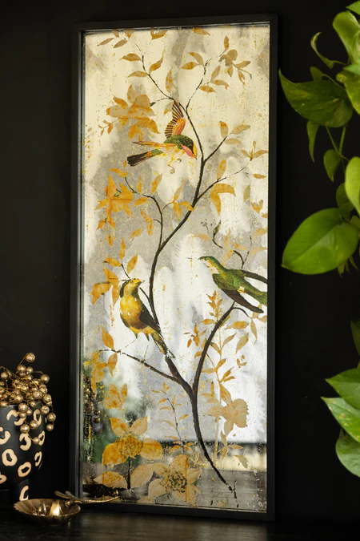The **Beautiful Bird Wall Art Mirror** is a stunning fusion of nature and elegance. Featuring intricate bird designs, this mirror brings a sense of serenity and beauty to any room. The delicate birds, perched gracefully around the mirror's edge, add a natural, whimsical touch to your decor. Ideal for living rooms, bedrooms, or hallways, this piece serves as both a functional mirror and an enchanting work of art. With its artistic details and reflective surface, it brightens any space while infusing it with a sense of calm and charm, making it a perfect addition for nature lovers and art enthusiasts alike.